Surrealism taps the unconscious mind to release the power of creativity and imagination. The Surrealist movement started during the collapse of the Dada movement, which was centered in Paris, and shared the same characteristic of anti-rationalism. The movement was officially founded in 1924 by André Breton, when he wrote the Manifesto of Surrealism (Art Story). Breton stated in the Manifesto, “I believe in the future transmutation of those two seemingly contradictory states, dream and reality, into a sort of absolute reality, or surreality, so to speak” (Breton, 11). Breton supported automatism, which stated that artists should bypass rationality by accessing their unconscious mind when creating art. Automatism was one of the two styles shown in Surrealist paintings. Hyper-realism, the other Surrealist style, consisted of painting objects in sharp detail and including illusions of three-dimensionality, which emphasized the paintings dream-like quality. Some Surrealist artists used both styles in their works of art. Sigmund Freud’s book The Interpretation of Dreams (1899), was a key point of inspiration for Surrealists. Freud preached how dreams are important because of the meaning behind them, and how the unconscious holds repressed emotions and desires.
Salvador Dalí was a key artist in the Surrealist movement. Salvador Dalí, born May 11, 1904, in Figueres, Spain, was greatly inspired by Freud’s ideas. Dalí had an older brother, who he was named after, because he unfortunately passed away before Dalí was born. Dalí also had a younger sister, Ana Maria. Dalí was very artistically talented when he was young, so his parents sent him to art school. In the mid 1920’s, Dalí met Picasso and Magritte when he was travelling in Paris, artists who he admired and who introduced him to different styles of art. Although Spanish artist Salvador Dalí worked with Futurism, Cubism, and Impressionism, he was an icon of the Surrealist movement. Dalí was known for pioneering the paranoiac-critical method, which uses the subconscious to enhance artistic creativity. Breton said in his Manifesto that Surrealism “is somewhat like the tip of an iceberg. Its real value is that it marks, above the water line, the presence of something of far greater proportions, beneath the surface” (Matthews, 3). Dalí defined the paranoiac critical method as a process in which artists perceived multiple images within the same configuration. Dalí simulated a paranoid state, without the use of drugs, to create paintings with underlying meaning from the unconscious. He would recreate what he saw in his delusions to merge the real and the imagined, which can be seen in The Persistence of Memory, Dream caused by the Flight of a Bee around a Pomegranate One Second Before Awakening, and The Disintegration of the Persistence of Memory.
The Persistence of Memory, created in 1931 at the beginning of Dalí’s career, is probably Dalí’s most famous work of art. The piece’s landscape is a barren desert, with a tan jagged mountain in the top right corner, said to be inspiration from Catalonia, Spain (Dalí’s hometown). To the left of the mountain is a large lake of light blue water, along with a plain grey slate. The sky above the lake is a pale yellow which fades into a darker blue. The olive tree, on the left side of the painting on top of the wooden block, has no leaves which causes a melancholy tone in the work of art. In the middle of the dark brown desert lays a characteristic image of something that is not completely human. The creature is pale and white, with very long eyelashes that are insect like, and a tongue coming out of the nose. The most famous part of the piece is the four pocket watches. Three of the pocket watches are melting in various places in the painting. A silver pocket watch is draped on the olive tree branch and on the back of the abnormal creature. A golden pocket watch, with a fly on the face, is placed on the wooden block where the tree is rooted. The final pocket watch is orange, and instead of it melting like the other watches, it has a swarm of ants eating the face. The painting is mainly composed of warmer colors, but is balanced with the blue tint on the watch face, and the blue sky. The colors of the painting are saturated and dark, to illustrate a dream like environment.
The Persistence of Memory, has juxtaposed images to convey a dream-like state, which is frequent in Surrealist art. The melting of the pocket watches is supposed to symbolize the malleability of time. Watches are reliable when keeping track of time, but when dreaming time is harder to keep track of. The pocket watches are melting away to show how they have no power in the dream world. Dalí paints the watches to show how useless, and irrelevant, the normal concept of time is inside the dream state (Legomenon). Many Surrealists did not have value for middle class objects. Since pocket watches were popular in the 1920s and 30s, they are included in this work of art to show how their value for marking time is not important. The ants eating the face of the orange pocket watch symbolizes decay, and illustrates how as time passes things tend to decay. The abnormal creature resembles a distorted self-portrait of Dalí, based on the mustache above the eyelashes on the figure. The objects in the painting can be interpreted in many ways, which is why the painting employs the paranoiac- critical method created by Dalí. Dalí was known for painting what he saw in his hallucinations and delusions, which occurred during an altered state. The overlapping of reality and the imagined causes the painting to confuse viewers. Dalí stated in his Conquest of the Irrational, “My whole ambition in the pictorial domain is to materialize the images of my concrete irrationality with the most imperialist fury of precision” (Humboldt State University).
Salvador Dali’s masterpiece, Dream caused by the Flight of a Bee around a Pomegranate One Second Before Awakening, has Surrealist illusions that contrast one another. In the lower half of the piece a sleeping woman lies on a light grey rock, she is floating above the rock to illustrate how she is in a dream like state. The grey slate is in the middle of a vast blue sea with nothing surrounding it besides a small rock and a tall cliff in the far distance. Next to the woman is a floating red pomegranate with a barely visible bee flying around it. In the upper half of the canvas there is a series of animals and objects bursting from of a bigger version of an open pomegranate. The giant pomegranate releases a red orange goldfish, which then changes into a roaring tiger. Out of the tiger’s mouth emerges another tiger which has a rifle soaring out of it. The last tiger is pouncing forward towards the gun, which is pointing directly at the head of the sleeping woman. On the horizon line of the canvas there is a glass elephant with flamingo legs holding an obelisk on its back. The animals are painted in a warm color scheme, changing from red to yellow, while the background is mainly composed of a cool color scheme. Light blue, pale yellow, and light pink are the main colors of the landscape, causing the work of art to have a peaceful undertone. The vivid colors of the pomegranate and the animals are what bring the painting to life and grab people’s attention.
Although, Dream caused by the Flight of a Bee around a Pomegranate One Second Before Awakening, is a well-known work of art by Dali, it lacks an abundance of illusions on the subconscious level. The morphing of fruit to animal to gun is supposedly from the sleeping woman’s dream instead of from the subconscious. The work of art was one of Dali’s most popular post- Second World War era painting. The piece was created during a rut in Dali’s career, and focused on “state of immobility and suspended animation” due to new inspiration from nuclear fission and atomic missiles (Shanes). The animals are frozen mid leap, and the gun floats directly in front of the sleeping women, showing a state of immobility. The tiny floating pomegranate by the woman’s bedside has two drops of water on either side. The heart cast by the shadow of the pomegranate symbolizes the goddess of love, Venus. The glass elephant symbolizes destruction and war, tying in to the time in which it was created. The flamingo legs are long and unrealistic on the elephant, showing the dreamlike quality of the painting. This painting touches back on Dali’s previous inspiration, Freudian Psychoanalysis. The obelisk on the back of the elephant resembles an iceberg, which is a frequent analogy in Freud’s work. The further someone travels down the iceberg, the deeper they go into their subconscious. Dalí’s work has a dream like aspect to it because of the use of subconscious imagery, and causes the painting to hold more value based on the founding idea of Surrealism.
The Disintegration of the Persistence of Memory, created from 1952-1954, is a re-creation of Dalí’s work The Persistence of Memory (1931). The desert landscape is flooded from the lake in the original version. The mountain on the horizon line remains above water, and is slightly bigger than the one in the original piece. The reflection of the mountain is shown in the pastel blue surface of the water, but under the surface the water is a pale-yellow reflection of the sky and a dark blue at the bottom of the painting. Instead of one olive tree, the painting includes two barren olive trees partially submerged in the water. One of the olive trees is broken into parts, with a silver pocket watch draped over the extended branch. The dial on the watch floats above the actual face of the watch. The other olive tree is small and not broken into pieces in the far-left corner of the painting. Under the surface of the water are three golden pocket watches bending and rippling. This is different than the original painting which had two silver watches, one golden watch, and one orange pocket watch. The wooden block and the grey slate in the original painting are now divided into brick like shapes that float in relation to the original, without touching one another. Several golden horns, also under the surface of the water, are heading into the distance. The characteristic figure in the original painting has now morphed into a liquid figure that resembles the colorful fish above it. The fish has bright orange eye with orange and blue on its side. The contrasting colors bring attention to the animal, and make it one of the main focuses in the piece. The colors are brighter in The Disintegration of the Persistence of Memory, compared to the shadowed tones in The Persistence of Memory.
The Disintegration of the Persistence of Memory, created later in Dalí’s career, shows the changes between his earlier works of art and his later pieces. The floating bricks represent the breakdown of matter into atoms, which is a revelation in the age of quantum mechanics (Dalí paintings). Like The Persistence of Memory, which referenced time, the bricks encounter objects to show that time is not moving straight forward. The water line is pinned to the far-left tree without any grounding, so there is no defining line between the sky and the water. This ties back into Dalí’s Surrealist style by having nothing holding the painting together. The golden horns disappearing in the distance symbolize atomic missiles and destruction. The piece is Dalí’s most famous post-war painting showing his interests in physics and metaphysics, and his movement away from Surrealism. This re-creation piece digitalized the old painting with relevant ideas in Dalí’s life (quantum mechanics). Dalí discussed the work of art, “After twenty years of total immobility, the soft watches disintegrate dynamically, while the highly coloured chromosomes of the fish eye constitute the hereditary approach of my pre-natal activisms” (Shanes). The fish in the painting is supposed to represent a “skin that can be lifted”, which is an idea that Dalí worked with frequently after 1954. In Dalí’s point of view, the fish symbolized life, and it shows how his style changed over time.
Dalí was an icon in the Surrealist movement because he pioneered the “paranoiac-critical” method in the 1930s. When Surrealists used fantasy and dream imagery, they created new creative works of art that exposed their inner minds in symbolic ways, uncovering anxieties and “treating them analytically through visual means” (The Art Story). Bizarre imagery was also used in film to experiment with Surrealism. Dalí worked with the most famous Surrealist filmmaker, Luis Buñuel, and eventually created a dream sequence for Alfred Hitchcock’s Spellbound (1945). In 1934, Dalí was expelled from the Surrealist group that he started. Although he was a public supporter of Surrealism, he did not denounce fascism, which created trouble with artists in the Surrealist movement. During World War II, Dalí moved to America with his wife for eight years, along with many other Surrealist artists, which helped Surrealism spread west. The Persistence of Memory, Dream caused by the Flight of a Bee around a Pomegranate One Second Before Awakening, and The Disintegration of the Persistence of Memory, help show the differences in Dalí’s artwork over time as he moved from Surrealism to physics and metaphysics. Although Dalí passed away in 1989, his work, and the “paranoiac-critical” method, will always be remembered by the Surrealist movement.

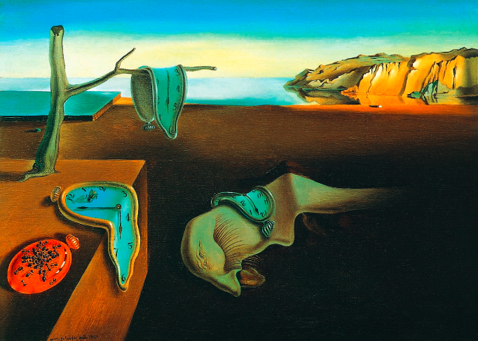
The Persistence of Memory (1931)

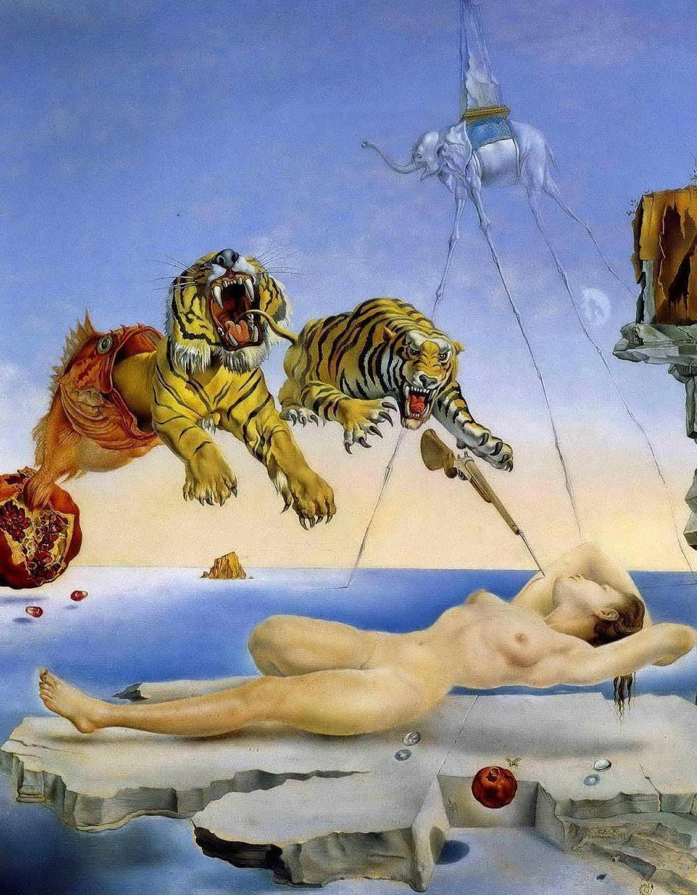

Dream caused by the Flight of a Bee around a Pomegranate One Second Before Awakening (1944)

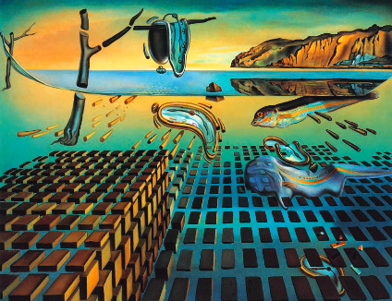
The Disintegration of the Persistence of Memory (1952-1954)

Works Cited

Matthews, J. H. “Fifty Years Later: The Manifesto of Surrealism.” Twentieth Century Literature, vol. 21, no. 1, 1975, pp. 1–9. JSTOR, JSTOR, www.jstor.org/stable/440524.
Jenny, Laurent, and Thomas Trezise. “From Breton to Dali: The Adventures of Automatism.” October, vol. 51, 1989, pp. 105–114. JSTOR, JSTOR, www.jstor.org/stable/778893.
Breton, André, et al. What is surrealism?. London:: Faber & Faber, 1936.
Surrealism. (2017). Columbia Electronic Encyclopedia, 6th Edition, 1.
Shanes, Eric. Salvador Dalí. Parkstone Press International , 2014.
"Salvador Dali Persistence of Memory: Meaning of the Melting Clocks." LEGOMENON: What Is the Meaning: Online Literary Journal & Magazine. N.p., n.d. Web.
“Surrealism Movement, Artists and Major Works.” The Art Story
“library.” Salvador Dali- The Paranoid Critical Transformation Method, Humboldt State University.

Salvador Dalí and Surrealism
By: Madison Duke
Student number: 14262971
Lab 1D

Appreciation of Art 1020 W
TA: Painter

I strive to uphold the University values of respect, responsibility discovery and excellence. On my honor, I pledge that I have neither given nor received unauthorized assistance on this work.
_____________________________________________________________Signature____________________

